DBMS Project Report

PES University

Database Management Systems

UE18CS252

Submitted By

|  |  |
| --- | --- |
| PES2201800156 | ESHAN NAIK |

|  |
| --- |
| An art gallery management system stores the details of paintings, photographs and sculptures in respective tables. It also stores details about the artists, the buyers and the sales each having their own tables. We use another table called artworks which stores the details of the art and the artists.  This system is used for helping a person buy any an art piece for himself or as a gift for someone. This system tells what and all art pieces are available for sale and also gives information on the art piece and the artist who made the piece.  Hence the system has a total of 7 tables with 4 1: N relations in total and a 1 M: N relationship.  This database has all 2NF and 3NF tables.  We used to create table for creating tables for the database and alter table for adding check constraints for the table.  The triggers where created around the selling price of an item and the usual price charged by that artist using create trigger.  There are 2 aggregate queries used, 1 correlated-nested query, 1 query that is both aggregate and correlated-nest and 2 join queries using left join and right join.  We conclude by saying this database is used to store information about an art gallery which can help a person buy art pieces and help the art gallery keep a track of the purchases. |

CONTENTS

Introduction 2

Data Model 2

FD and Normalization 5

DDL 8

Triggers 10

SQL Queries 11

Conclusion 12

# Introduction

* This system is used to maintain the market of an art gallery where people give their details which is stored in the table called buyer.
* The details of the artwork which the buyer would want to buy will be stored in a table called the artworks table. This table functions like the art gallery.
* The different forms of artwork each have their own tables. The different forms of artwork are painting, sculpture and photograph.
* Paintings have its details stored in a table called painting.
* Sculptures have its details stored in another table called sculpture.
* Finally, photographs have their details store in another table called photographs.
* The details of the artists who made the art are stored in a table called artists.
* The artwork is sold to a buyer hence here there is an M: N relationship called sale.

# Data Model

**Given below is the er diagram -**

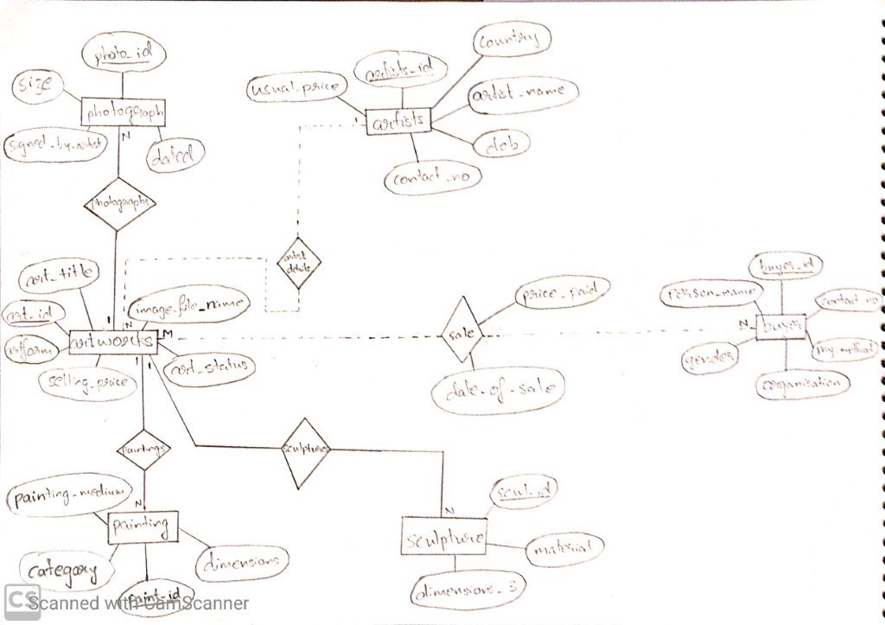

**Brief description of the ER diagram -**

* Artworks has attributes art_id, art_title , image_file_name, art_status, selling_price and artform, where art_id is the primary key.
* Artists has attributes artist_id, artist_name, dob, contact_no, country, usual_price, where artist_id is the primary key.
* Buyer has attributes buyer_id, organisation, person_name, gender, contact_no, pay_method, where buyer_id I a primary key.
* Sale has attributes price_paid, date_of_sale, which is a M: N relationship between artworks and buyer.
* Photographs has attributed photo_id, size,signed_by_artist, dated,where photo_id is the primary key.
* Painting has attributes painting_medium, category, paint_id, dimensions, where paint_id is a primary key.
* Sculpture has attributes scul_id, material, dimensions_3.
* The relationship from artworks to painting,sculpture and painting are all 1: N as there can be multiply paintings, sculptures, photographs but only one art gallery. It is an identifying relationship.
* The relationship between art gallery and buyer is a M: N relationship as multiple buyers can buy multiple art pieces from the same art gallery. and the relation is called sale. It is a non-identifying relationship.
* Sale stores the details of the purchase made by the buyer.
* The relation between artists and artworks is a 1: N relationship as there will be only a single artist who can give many art pieces to the art gallery. It is a non-identifying relation.

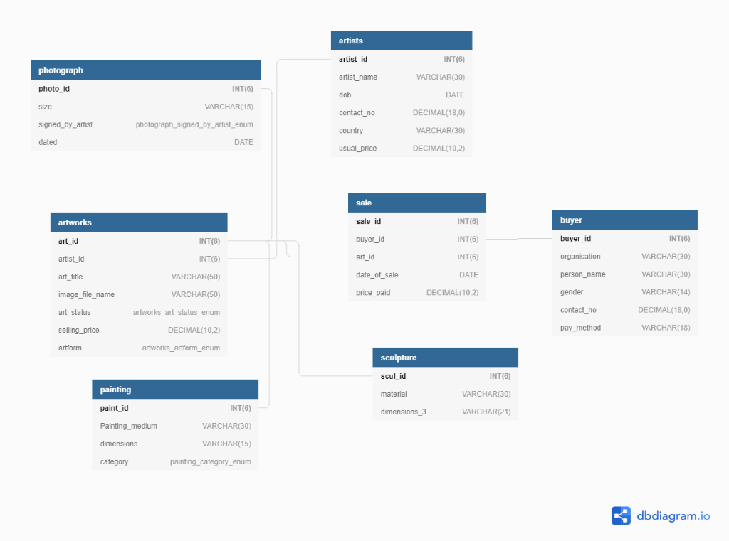

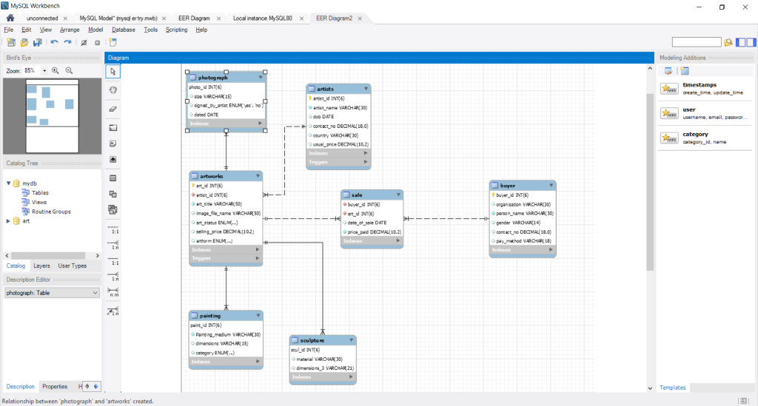

# FD and Normalization

artists(artist_id,artist_name,dob,contact_no,country,usual_price)

Functional dependencies:

artist_id -> artist_name

artist_id -> dob

artist_id -> contact_no

artist_id -> country

artist_id -> usual_price

Here artist_id is a candidate key and is the only candidate key.

Hence the relation is 2NF as there are no partial dependencies.

The relation is 3NF as there are no transition dependencies.

artworks(art_id,art_title,artform,selling_price,art_status, image_file_name)

Functional dependencies:

art_id -> art_title

art_id -> artform

art_id -> selling_price

art_id -> art_status

art_id -> image_file_name

Here art_id is a candidate key and is the only candidate key.

Hence the relation is 2NF as there are no partial dependencies.

The relation is 3NF as there are no transition dependencies.

buyer(buyer_id,organisation, person_name,gender,contact_no,pay_method)

Functional dependencies:

buyer_id -> organisation

buyer_id -> person_name

buyer_id -> gender

buyer_id -> contact_no

buyer_id -> pay_method

Here buyer_id is a candidate key and is the only candidate key.

Hence the relation is 2NF as there are no partial dependencies.

The relation is 3NF as there are no transition dependencies.

painting(paint_id,painting_medium,dimensions,category)

Functional dependencies:

paint_id -> painting_medium

paint_id -> dimensions

paint_id -> category

Here paint_id is the only candidate key.

The relation is 2NF as there are no partial dependencies

The relations are 3NF as there are no transition dependencies

photograph(photo_id,size,signed_by_artist,dated)

Functional dependencies:

photo_id -> size

photo_id -> signed_by_artist

photo_id -> dated

Here photo_id is a candidate key and the only candidate key.

Hence the relation is 2NF as there are no partial dependencies.

The relation is also 3NF as there are no transitive dependencies.

sale(buyer_id,art_id,date_of_sale,price_paid)

Functional dependencies:

{buyer_id,art_id} -> date_of_sale

{buyer_id,art_id} -> price_paid

Here {sale_id,buyer_id,art_id} is a candidate key and is the only candidate key.

Hence the relation is 2NF as there are no partial dependencies.

The relation is 3NF as there are no transition dependencies.

sculpture(scul_id,material,dimensions_3)

Functional depencies:

scul_id -> material

scul_id -> dimensions_3

Here scul_id is a candidate key and the only candidate key.

Hence the relation is 2NF as there are no partial dependencies.

The relation is also 3NF as there are no transitive dependencies.

**Discussion on which normal form will be violated if 2 relations are combined**

Ex 1: When we combine tables sale and buyer then

buyer_id -> organisation

buyer_id -> person_name

buyer_id -> gender

buyer_id -> contact_no

buyer_id -> pay_method

{buyer_id,art_id} -> date_of_sale

{buyer_id,art_id} -> price_paid

The closure of buyer_id = { organisation,person_name, gender,contact_no,pay_method}, that is, buyer_id is not the candidate key in this combined table.

Now the closure of {buyer_id,art_id} = { organisation,person_name, gender, contact_no, pay_method, price_paid, date_of_sale}. This tells us that {buyer_id,art_id} is the candidate key.

This show that when we combine the tables sale and buyer then there will be a 2NF violation because of partial dependencies like buyer_id ->organisation and buyer_id ->person_name.

Ex 2: If we take the tables artwork and sale

art_id -> art_title

art_id -> artform

art_id -> selling_price

art_id -> art_status

art_id -> image_file_name

{buyer_id,art_id} -> date_of_sale

{buyer_id,art_id} -> price_paid

The closure of art_id ={art_title, artform, selling_price, art_status, image_file_name}. This tells us that art_id is not a candidate key for the combined table.

Now the closure of {buyer_id,art_id} = { art_title, artform, selling_price, art_status, image_file_name, price_paid, date_of_sale}. This shows that {buyer_id,sale_id} is the candidate key as it has all the attributes of the combined table.

Now we can say that this violates 2NF as there are partial dependencies like art_id -> art_title and art_id -> artform.

Ex 3: If we take the tables sculpture and artworks

art_id -> art_title

art_id -> artform

art_id -> selling_price

art_id -> art_status

art_id -> image_file_name

art_id -> scul_id

scul_id -> material

scul_id -> dimensions_3

The closure of scul_id = {material, dimensions_3}. This tells us that scul_id is not a candidate key for the combined table.

Now the closure of art_id ={art_title, artform, selling_price, art_status, image_file_name, dimensions_3, scul_id, dimensions_3, material}. This shows that art_id is the candidate key as it has all the attributes of the combined table.

Now we can say that this violates 3NF as there are transition dependencies like art_id -> scul_id and scul_id -> dimensions_3, hence art_id -> dimensions_3.

# DDL

**Creating Tables**

CREATE TABLE IF NOT EXISTS `art`.`artists` (

`artist_id` INT(6) NOT NULL AUTO_INCREMENT,

`artist_name` VARCHAR(30) NOT NULL,

`dob` DATE NULL DEFAULT NULL,

`contact_no` DECIMAL(18,0) NULL DEFAULT NULL,

`country` VARCHAR(30) NULL DEFAULT NULL,

`usual_price` DECIMAL(10,2) NULL DEFAULT NULL,

PRIMARY KEY (`artist_id`))

CREATE TABLE IF NOT EXISTS `art`.`artworks` (

`art_id` INT(6) NOT NULL,

`artist_id` INT(6) NOT NULL,

`art_title` VARCHAR(50) NOT NULL,

`image_file_name` VARCHAR(50) NULL DEFAULT NULL,

`art_status` ENUM('available', 'sold', 'reserved', 'consigned out') NULL DEFAULT 'available',

`selling_price` DECIMAL(10,2) NULL DEFAULT NULL,

`artform` ENUM('painting', 'photograph', 'sculpture') NULL DEFAULT 'painting',

PRIMARY KEY (`art_id`),

INDEX `artist_id` (`artist_id` ASC) VISIBLE,

CONSTRAINT `artworks_ibfk_1`

FOREIGN KEY (`artist_id`)

REFERENCES `art`.`artists` (`artist_id`)

ON DELETE RESTRICT

ON UPDATE CASCADE)

CREATE TABLE IF NOT EXISTS `art`.`buyer` (

`buyer_id` INT(6) NOT NULL AUTO_INCREMENT,

`organisation` VARCHAR(30) NULL DEFAULT NULL,

`person_name` VARCHAR(30) NOT NULL,

`gender` VARCHAR(14) NULL DEFAULT NULL,

`contact_no` DECIMAL(18,0) NULL DEFAULT NULL,

`pay_method` VARCHAR(18) NULL DEFAULT NULL,

PRIMARY KEY (`buyer_id`))

CREATE TABLE IF NOT EXISTS `art`.`painting` (

`paint_id` INT(6) NOT NULL AUTO_INCREMENT,

`Painting_medium` VARCHAR(30) NOT NULL,

`dimensions` VARCHAR(15) NULL DEFAULT NULL,

`category` ENUM('landscape', 'portrait', 'abstract', 'still-life') NULL DEFAULT 'landscape',

PRIMARY KEY (`paint_id`),

CONSTRAINT `painting_ibfk_1`

FOREIGN KEY (`paint_id`)

REFERENCES `art`.`artworks` (`art_id`)

ON DELETE RESTRICT

ON UPDATE CASCADE)

CREATE TABLE IF NOT EXISTS `art`.`photograph` (

`photo_id` INT(6) NOT NULL,

`size` VARCHAR(15) NULL DEFAULT NULL,

`signed_by_artist` ENUM('yes', 'no') NULL DEFAULT 'yes',

`dated` DATE NULL DEFAULT NULL,

PRIMARY KEY (`photo_id`),

CONSTRAINT `photograph_ibfk_1`

FOREIGN KEY (`photo_id`)

REFERENCES `art`.`artworks` (`art_id`)

ON DELETE RESTRICT

ON UPDATE CASCADE)

CREATE TABLE IF NOT EXISTS `art`.`sale` (

`buyer_id` INT(6) NOT NULL,

`art_id` INT(6) NOT NULL,

`date_of_sale` DATE NULL DEFAULT NULL,

`price_paid` DECIMAL(10,2) NOT NULL,

INDEX `buyer_id` (`buyer_id` ASC) VISIBLE,

INDEX `art_id` (`art_id` ASC) VISIBLE,

CONSTRAINT `sale_ibfk_1`

FOREIGN KEY (`buyer_id`)

REFERENCES `art`.`buyer` (`buyer_id`)

ON DELETE RESTRICT

ON UPDATE CASCADE,

CONSTRAINT `sale_ibfk_2`

FOREIGN KEY (`art_id`)

REFERENCES `art`.`artworks` (`art_id`)

ON DELETE RESTRICT

ON UPDATE CASCADE)

CREATE TABLE IF NOT EXISTS `art`.`sculpture` (

`scul_id` INT(6) NOT NULL,

`material` VARCHAR(30) NULL DEFAULT 'stone',

`dimensions_3` VARCHAR(21) NULL DEFAULT NULL,

PRIMARY KEY (`scul_id`),

CONSTRAINT `sculpture_ibfk_1`

FOREIGN KEY (`scul_id`)

REFERENCES `art`.`artworks` (`art_id`)

ON DELETE RESTRICT

ON UPDATE CASCADE)

**CHECK CONSTRAINTS**

ALTER TABLE artists ADD CONSTRAINT age_restriction CHECK (dob between ‘1920-01-01' AND ‘2002-05-22');

ALTER TABLE buyer ADD CONSTRAINT check_pay_method CHECK (pay_method in (‘Debit Care’, ‘Credit Card’, ‘Cheque’);

# Triggers

We know that the usual price of charged by an artists cannot be a negative value so we can use a trigger to make sure that if the usual price an artist charges is entered as a negative value by mistake we should make it 0, which means the artists does work for free.

USE `art`;

DELIMITER $$

USE `art`$$

CREATE

DEFINER=`root`@`localhost`

TRIGGER `art`.`before_usual_price`

BEFORE INSERT ON `art`.`artists`

FOR EACH ROW

BEGIN

IF NEW.usual_price < 0 THEN SET NEW.usual_price = '0';

END IF;

END$$

We know that the price of any art piece cannot be negative so we make a trigger to make selling price to 0 if it is inputted as a negative number.

USE `art`$$

CREATE

DEFINER=`root`@`localhost`

TRIGGER `art`.`before_selling_price`

BEFORE UPDATE ON `art`.`artworks`

FOR EACH ROW

BEGIN IF NEW.selling_price < 0 THEN SET NEW.selling_price = 0;

END IF;

END$$

# SQL Queries

**Aggregate Functions**

**SQL query to count the number of female buyers**

select count(gender) from buyer

where gender = 'Female';

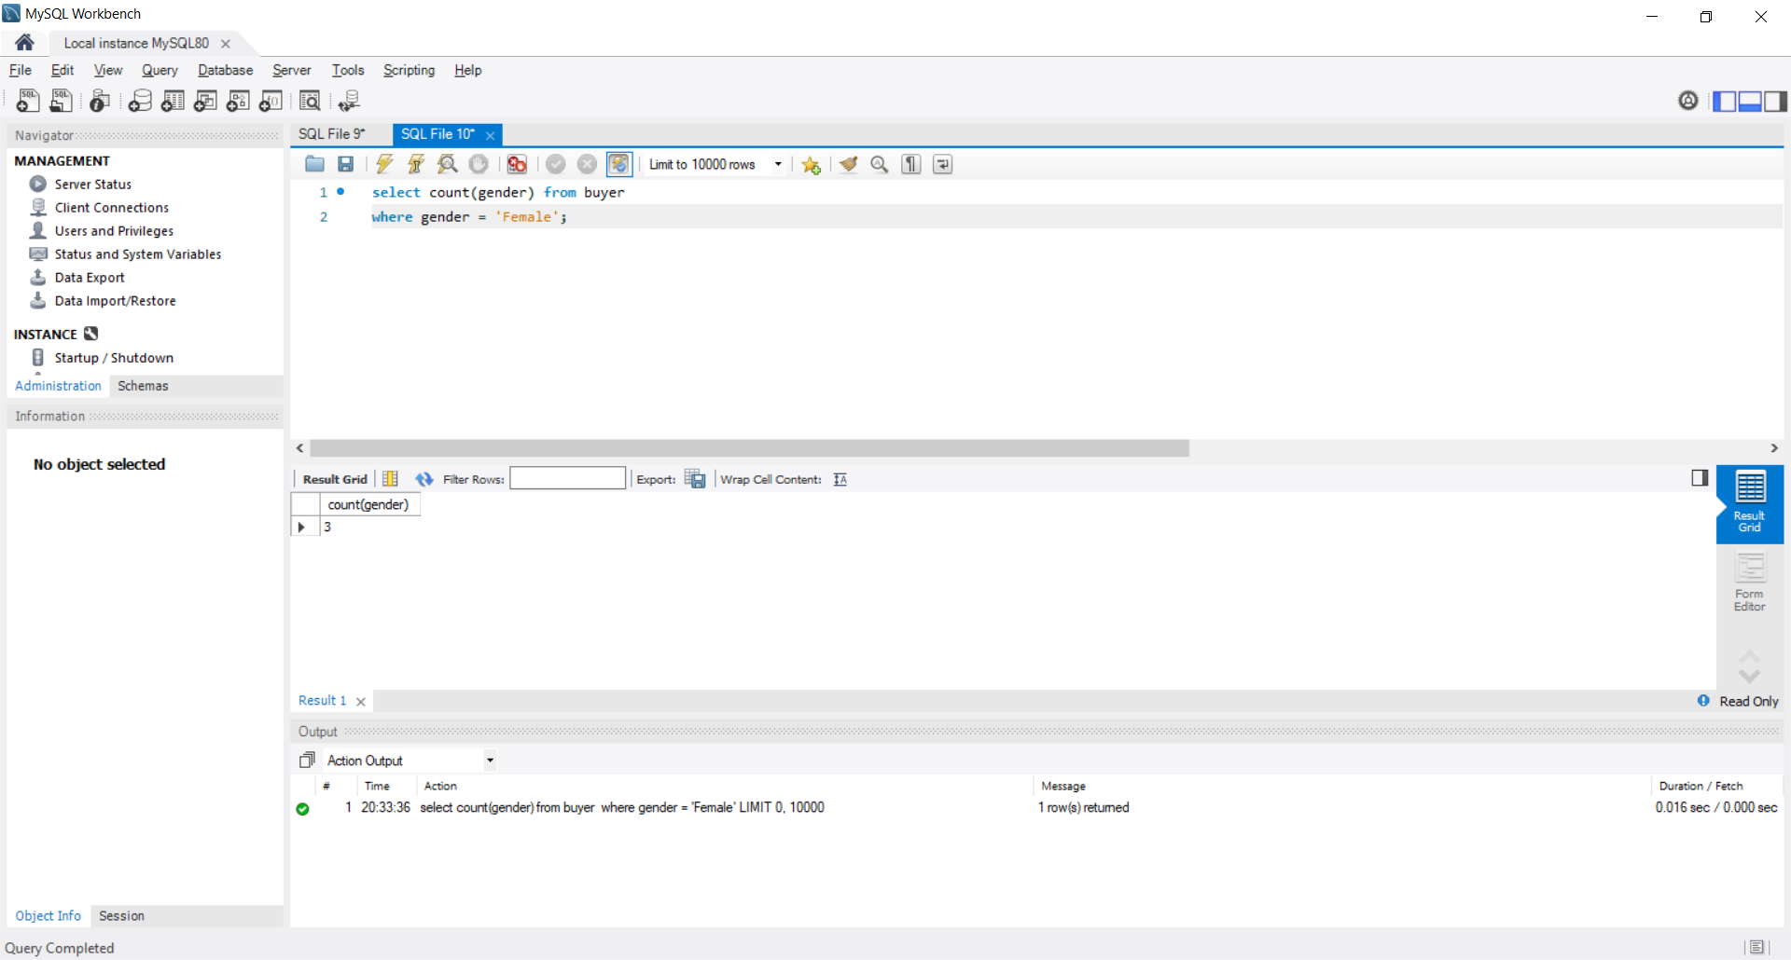

**SQL query to find the sum of sales in the year 2013**

select sum(price_paid) from sale

where year(date_of_sale) = 2012;

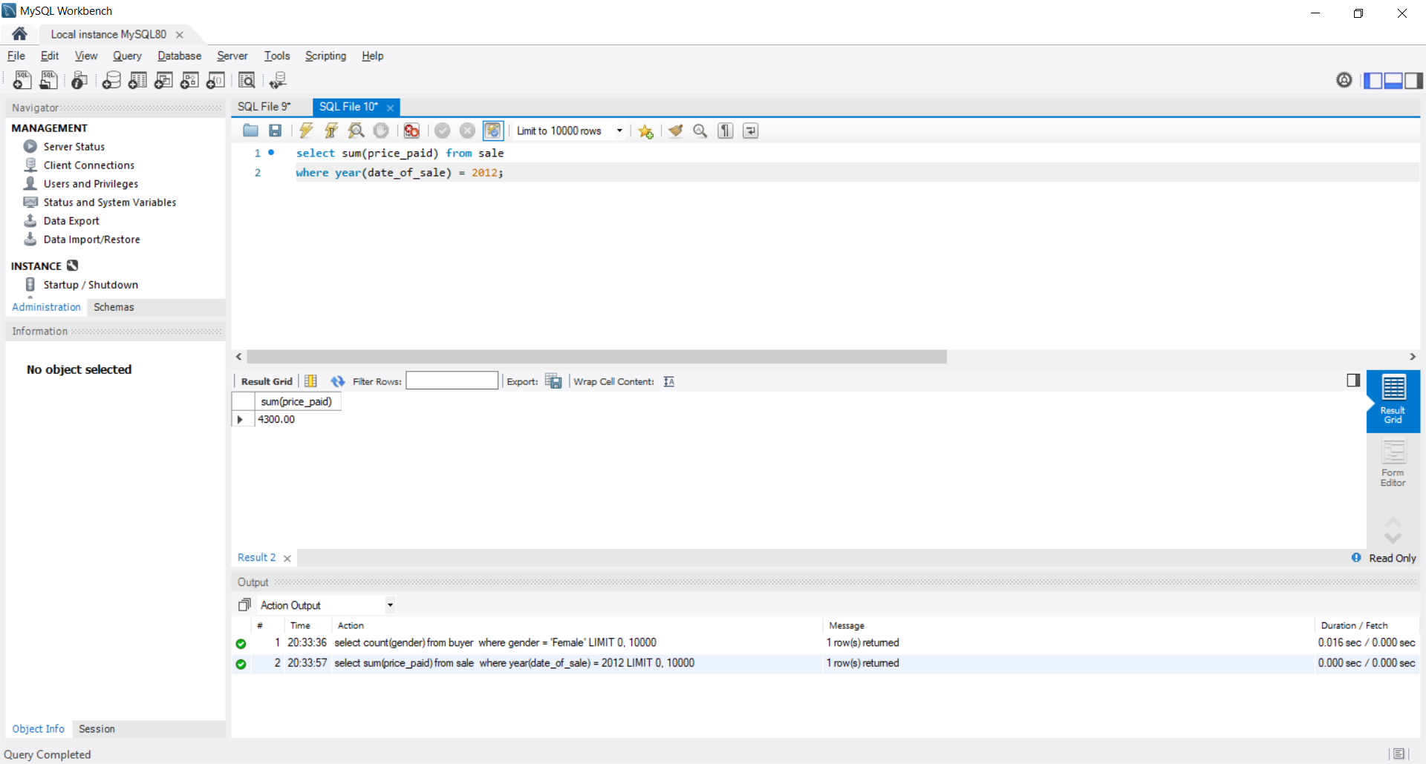

**Join functions**

**SQL query for a left join between artist name and the title of his art piece**

select artists.artist_name,artworks.art_title from artists

left join artworks on

artworks.artist_id = artists.artist_id

order by artists.artist_id ;

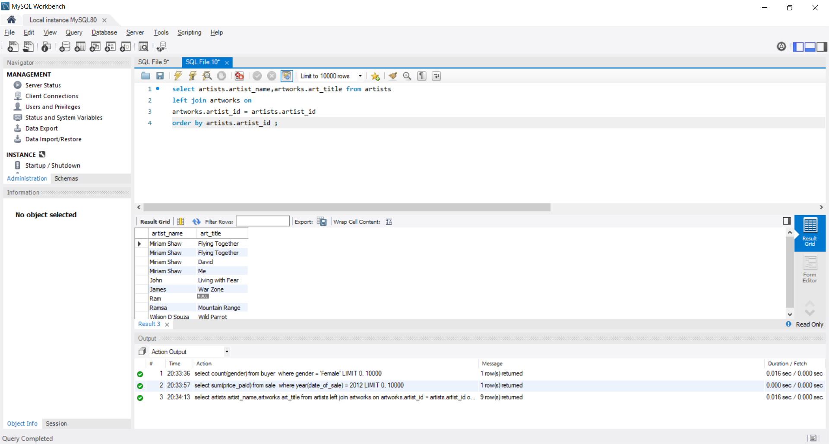

**SQL query for a right join between artist name the usual price he charges and the price at which he sold it**

select artists.artist_name,artists.usual_price,artworks.selling_price from artworks

right join artists on

artworks.artist_id = artists.artist_id

order by artists.artist_id ;

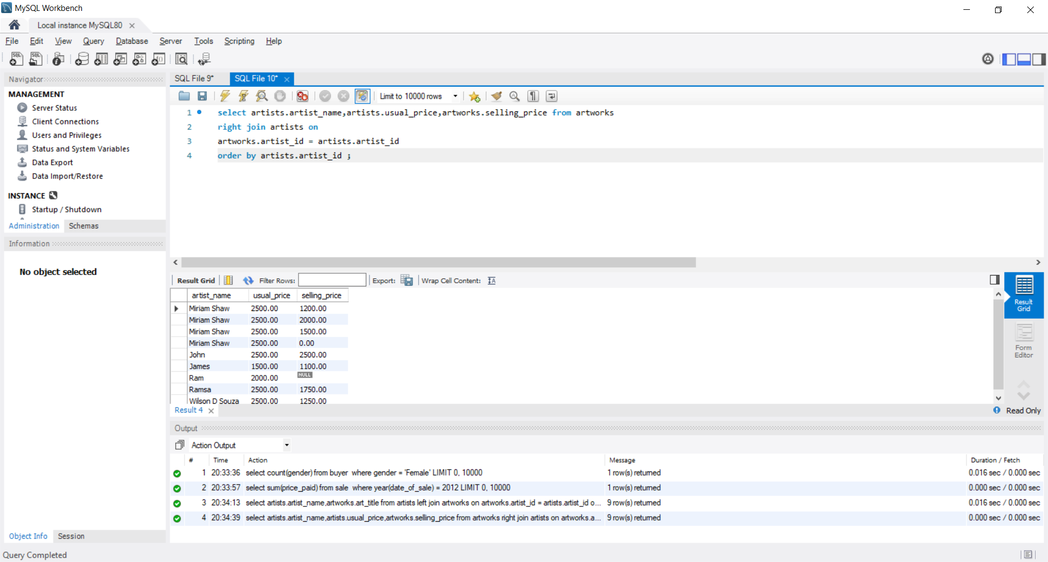

**Correlated Functions**

**SQL query which shows the available paintings which are for sale and are made from oil.**

select a.art_title, a.selling_price

from artworks a where a.art_status = 'available'

and a.art_id in (select paint_id from painting p

where p.painting_medium = 'oil');

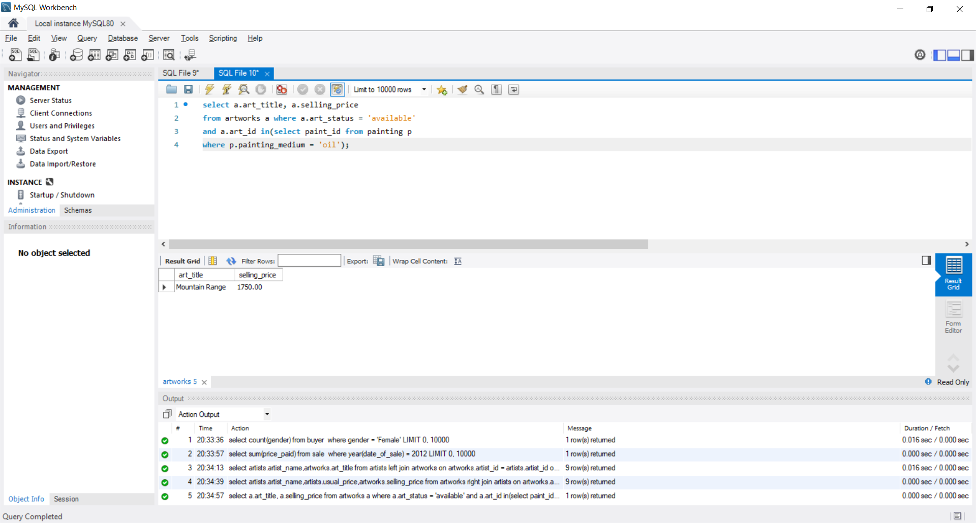

**SQL query to find total sales on painting**

select sum(s.price_paid)

from sale s

where art_id in (select art_id from artworks a where artform = 'painting');

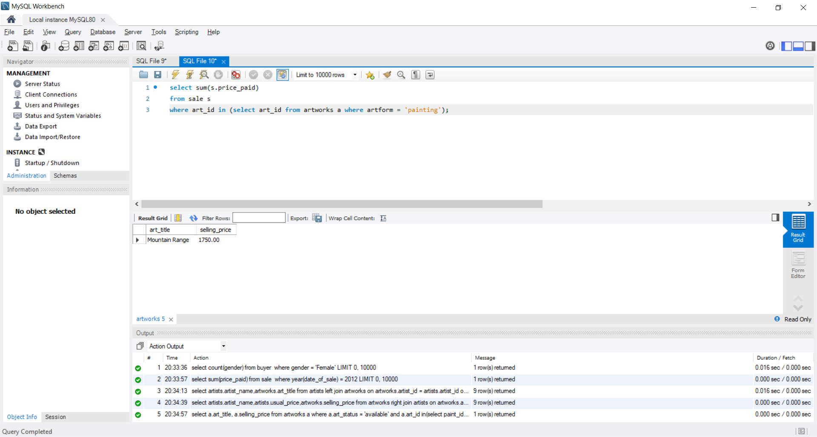

# Conclusion

We can conclude that this database can be used by a person to find artwork he would like to purchase and help the art gallery maintain a database for all the artwork the art gallery is selling.

We use triggers to make sure that selling price of any artwork is not a negative number but instead will be set to 0, that is, it will be sold for free.

The sql queries we use are to find the maximum money made from a single art piece or to count the total number of art pieces for sale. It is also used to find out more details about the sales of the art gallery.

Future Work:

I would like to add more artforms to the art gallery and also make it so the we can deliver the artwork. Increase the amount of info stored about the artworks and artists.